Name: Nilanjan Ghosh
College: SRM Institute of Science and Technology
Course: Java FSE Digital Nurture
Week 1

Exercise 1: Singleton Pattern
Aim
To implement the Singleton Design Pattern in Java.
Theory
The Singleton Pattern is a Creational Design Pattern that ensures only one instance of a class exists and provides a global point of access to it.
Algorithm
- Create a class Logger.
- Make its constructor private.
- Create a private static instance variable.
- Create a public static method getInstance().
- Return the same instance whenever called.
- Test using multiple references.
Program
Paste the full code for:
Logger.java
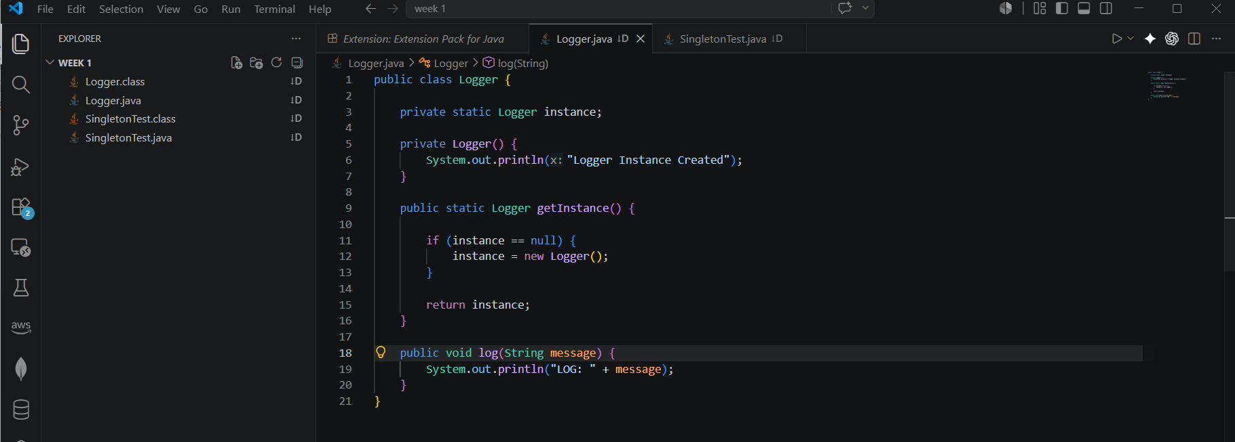

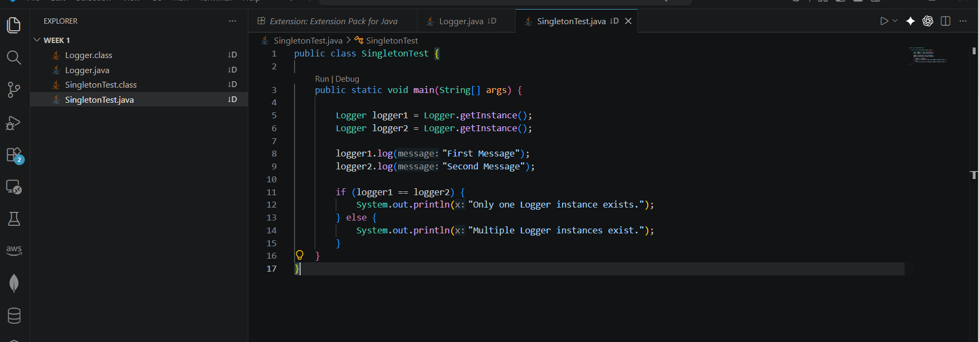
SingletonTest.java

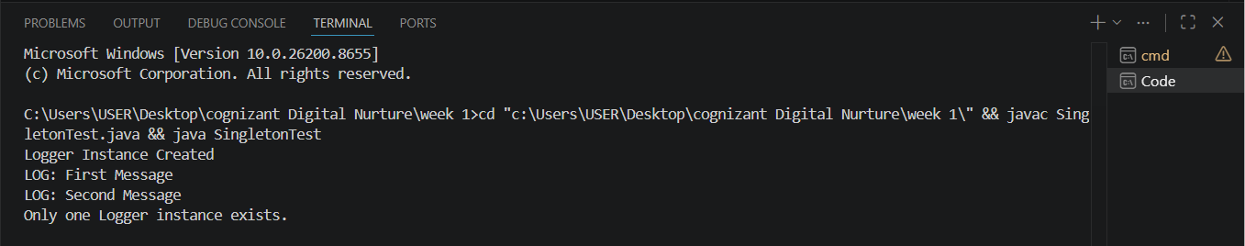
OUTPUT:

Result
The Singleton Pattern was successfully implemented and verified.

Exercise 2: Implementing the Factory Method Pattern
Aim
To implement the Factory Method Design Pattern for creating different types of documents such as Word, PDF, and Excel documents.
Theory
The Factory Method Pattern is a Creational Design Pattern that provides an interface for creating objects while allowing subclasses or factory methods to determine the type of object to create. This pattern helps in achieving loose coupling between object creation and usage.
Algorithm
- Create an interface named Document.
- Define an open() method in the interface.
- Create WordDocument, PdfDocument, and ExcelDocument classes implementing the Document interface.
- Create a DocumentFactory class to generate different document objects.
- Create a test class to demonstrate the creation of various document types.
- Execute the program and verify the output.
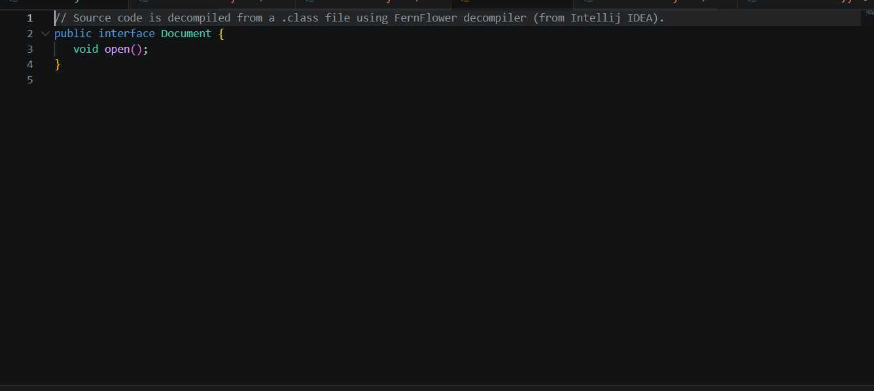
Program

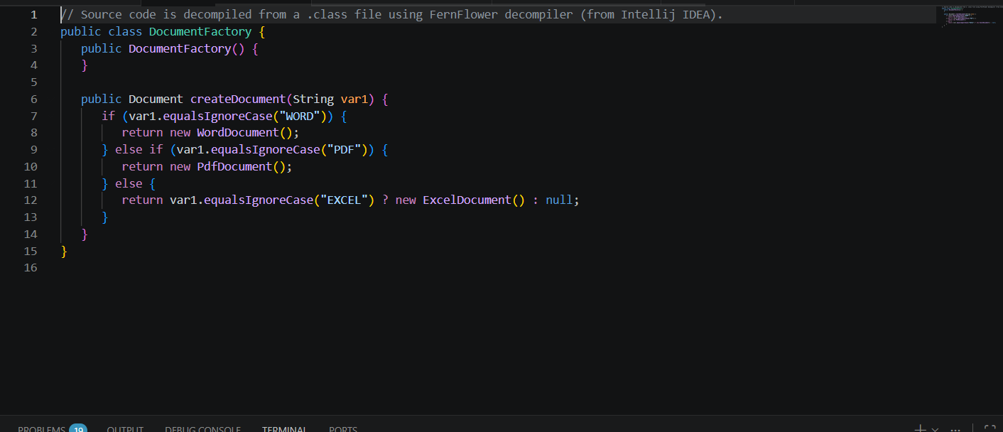
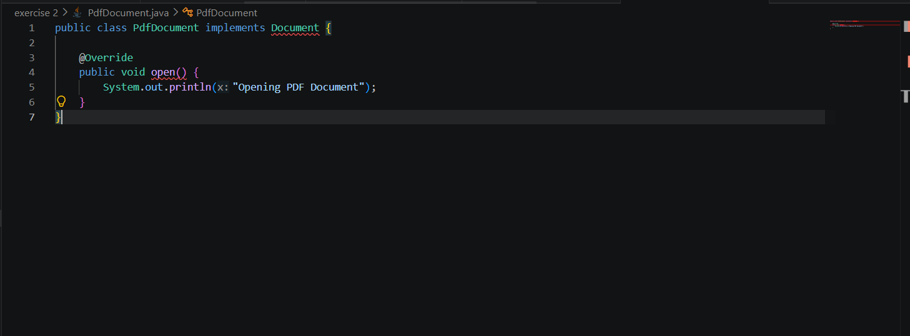

ExcelDocument.java
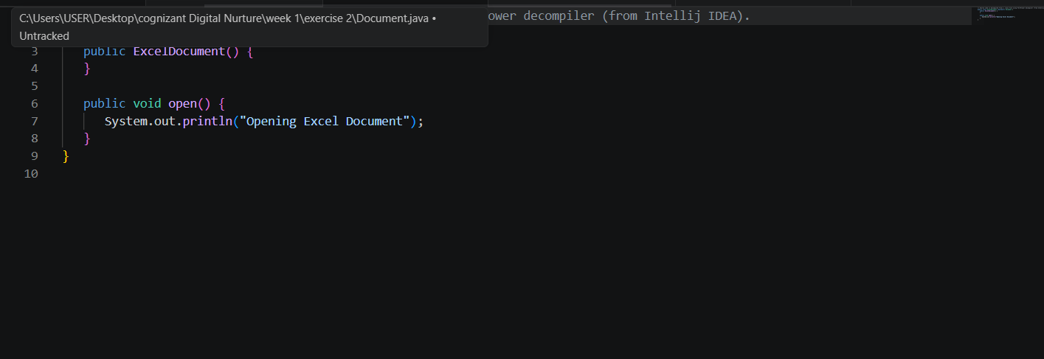
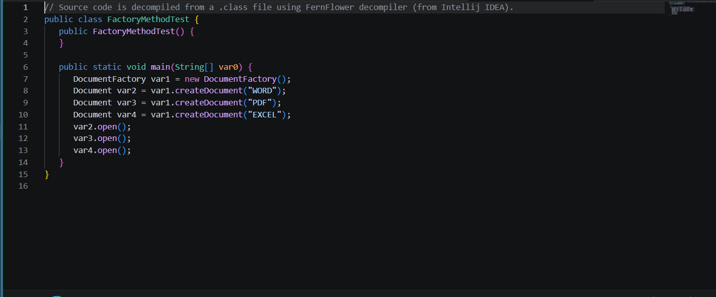
Factorymethodtest.java

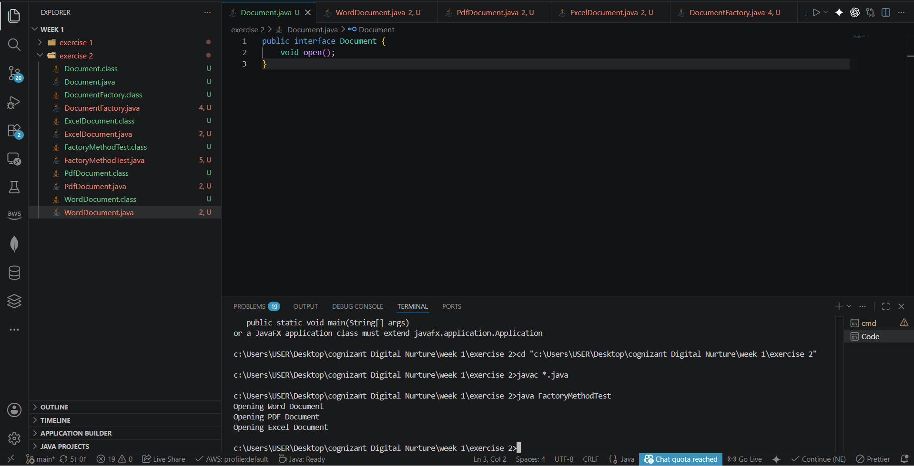
Output

Result
Thus, the Factory Method Design Pattern was successfully implemented to create Word, PDF, and Excel documents using a factory.

